**Please use the following technologies to complete this QA task:**

* Visual Studio or Eclipse for development and execution
* C# or Java
* Specflow (BDD) or Cucumber (BDD)
* Selenium WebDriver
* Chrome

**Automation Scenario:**

Navigate to https://ebay.com/.

Verify that the page is correct and opened

* Select from drop down list “Toys & Games”, then search for Monopoly

1. Verify that the first items has the title: Monopoly
2. Verify that there is a shipping to : Bulgaria
3. Verify that there is a price of the item

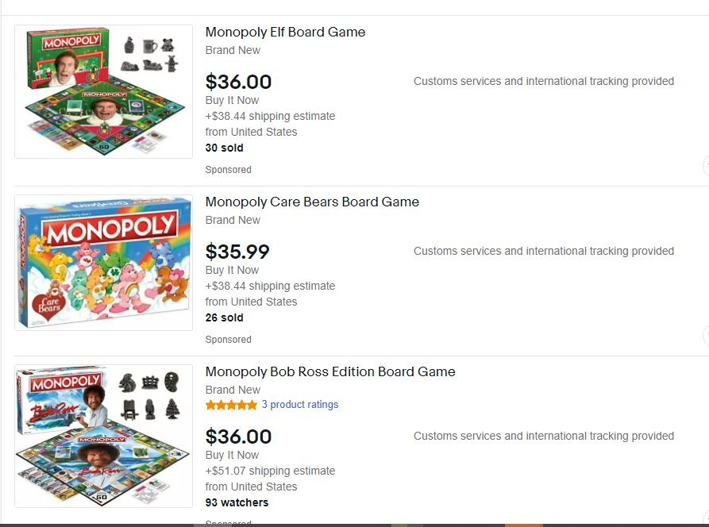

* Then click on the first item in order to navigate to details page
  + - Verify that the title of the item contains “Monopoly”
    - Verify that the price is the same as on the first page

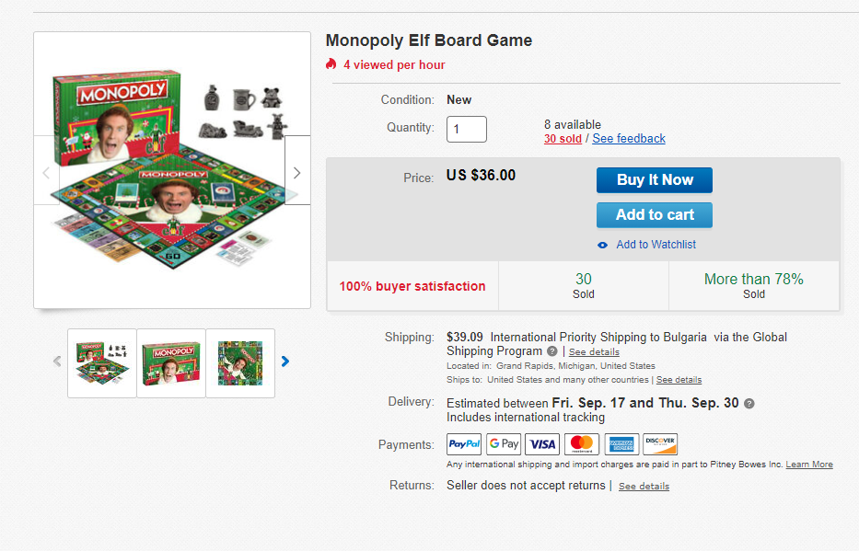

* + - Switch view from “Description” to “Shipping and payments” and verify that Bulgaria exists in the country drop down list.

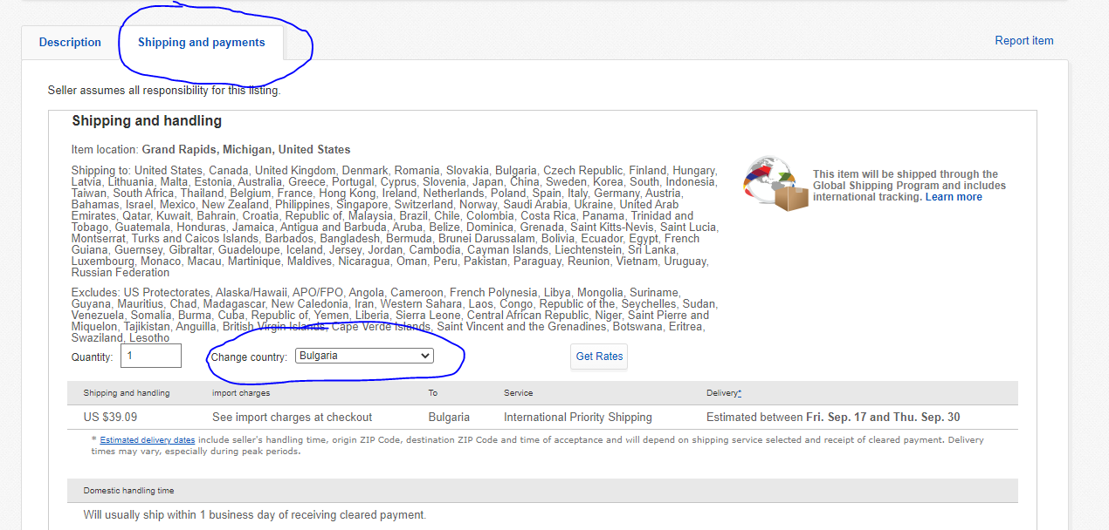

* Select quantity “2” and click “Add to cart ”
  + - Verify that you are on “https://cart.payments.ebay.com/”
    - Verify that in the Qty Drop Down List the quantity is “2”
    - Verify that the price is displayed for “2” items

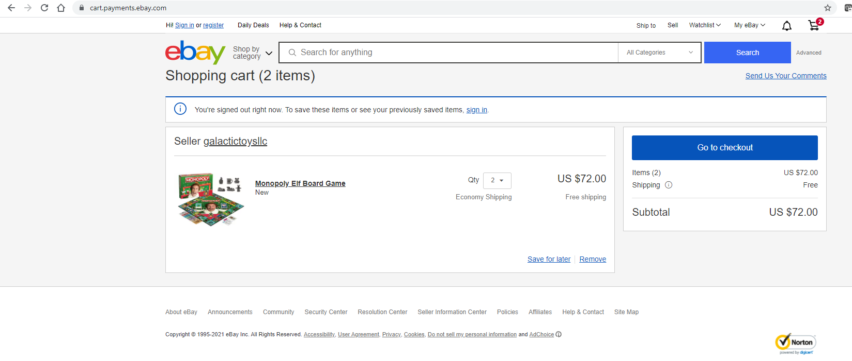

Good Luck !